Installing WinFluor

Double-click on the WinFluor V2.3.0.ZIP archive (note you will need WinZip installed on your computer for this) to open it, then click the INSTALL button on the WinZip tool bar to start the setup program.

Note. You need to be logged as a Windows 2000 user administrator privileges to install WinFluor (this should be the case for the account you normally run Lasersharp with).

On completion of the installation, WinFluor V2.3.0 is installed in the folder c:\Winfluor.

Copy the two script files “WinFluor Line Scan.txt” and “WinFluor XY Series.txt” from the c:\Winfluor folder to the c:\Lasersharp NT\Scripts folder.

Setting up WinFluor

Select Setup/Analogue Inputs Setup and make sure the analogue input channels are set up as below. (except that the A/D Converter Voltage range should be +/-10V)

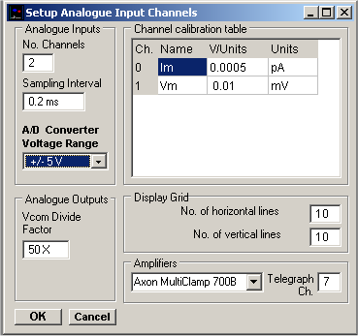

Recording line scans

Lasersharp: Load and run BioRad Helper.txt script (once only at start of session).

Lasersharp: Set size/zoom/orientation of image using Lasersharp control panel

Lasersharp: Display Line Scan window

Lasersharp: Select Triggering panel, Tick Enable Trigger (Trigger Once) box.

Lasersharp: Select Line Scan panel and enter number of scan line to be acquired into Scan Line field.

WinFluor: Select Record/Record (LSM) to display the analogue signals.

WinFluor: Select the stimulus command voltage protocol to be used during the line scan.

Lasersharp: Run WinFluor Line Scan.txt script

Lasersharp: Enter WinFluor IDR file name to hold line scans

Lasersharp: Enter experiment identification line

Lasersharp: Enter No. lines to acquire

Lasersharp: Enter scan line (same as in Line Scan window)

Lasersharp: Enter Pane # to be exported (default = 1)

Lasersharp: Click OK to start line scanning

On completion of the script, the line scan image acquired by Lasersharp is automatically exported to a WinFluor data file, combined with the analogue signals and displayed as a line scan within WinFluor. A PIC file showing the whole image from which the scan line was acquired is also saved.

Recording XY Series

Lasersharp: Load and run BioRad Helper.txt script (once only at start of session).

Lasersharp: Set size/zoom/orientation of image using Lasersharp control panel

Lasersharp: Display XY Series window

Lasersharp: Select Triggering panel, Tick Enabled box and Select Trigger Once option.

Lasersharp: Select Time Series panel and set Cycle Time = 0.

WinFluor: Select Record/Record (LSM) to display the analogue signals.

WinFluor: Select the stimulus command voltage protocol to be used during the series.

Lasersharp: Run WinFluor XY Series.txt script

Lasersharp: Enter WinFluor IDR file name to hold line scans

Lasersharp: Enter experiment identification line

Lasersharp: Enter No. of frames to acquire

Lasersharp: Enter Pane # to be exported (default = 1)

Lasersharp: Click OK to start XY Series collection

On completion of the script, the image series acquired by Lasersharp is automatically exported to a WinFluor data file, combined with the analogue signals and displayed within WinFluor.

